*//Q1. WACP to reverse a given string (of characters) without using library function.*

*#include*<stdio.h>

*#include*<string.h>

*#include*<stdlib.h>

int main(){

char str[100];

printf("Enter the string:\n");

fgets(str,100,stdin);

printf("Before reversing:\n");

puts(str);

int n = strlen(str)-1;

int lo=0, hi=n-1, temp;

*while*(lo<=hi){

temp = str[lo];

str[lo] = str[hi];

str[hi] = temp;

lo++;

hi--;

}

printf("After reversing:");

puts(str);

*return* 0;

}

**Output:**

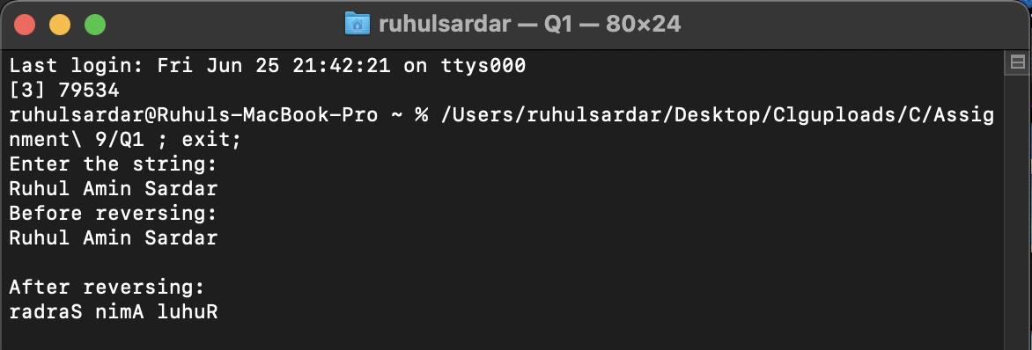

*//Q2. Write your own strcpy(), strcat(), strlen (), strcmp() functions in C.*

*#include*<stdio.h>

*#include*<string.h>

*#include*<stdlib.h>

void stringCopy();*//for strcpy()*

void stringAdd();*//for strcat()*

int stringLength();*//for strlen()*

int stringCompare();*//strcmp()*

*//Function to find the length of a string.*

int stringLength(char* Str){

int i;

*for* (i = 0; Str[i] != '\0'; i++);

*return* i;

}

*//Function to copy one string to another.*

void stringCopy(char* str1, char* str2){

*for*(int i=0; str1[i]!='\0'; i++){

str1[i]=str2[i];

}

puts(str1);

}

*//Function to compare 2 strings.*

int stringCompare(char* str1, char* str2){

int i=0;

*while*(str1[i]!='\0' || str2[i]!='\0'){

*if*(str1[i]==str2[i])

i++;

*break*;

}

*if*(str1[i]==str2[i])

*return* 0;

*else*

*return* 1;

}

*//Function to add 2 strings.*

void stringAdd(char* str1, char* str2){

int i=0;

*while*(str1[i]!='\0'){

i++;

}

*for*(int j=0 ; str2[j]!='\0'; i++,j++){

str1[i] = str2[j];

}

int n = stringLength(str1);

str1[n] = '\0';

puts(str1);

}

int main(){

char str1[100], str2[100];

printf("Enter Str1 :");gets(str1);

printf("Enter Str2 :");gets(str2);

printf("\nStr1 is :");puts(str1);

printf("\nStr2 is :");puts(str2);

int n1 = stringLength(str1);

int n2 = stringLength(str2);

printf("\nSize of str1 is %d",n1);

printf("\nSize of str2 is %d",n2);

printf("\n\nAfter adding str2 on str1:\n");

stringAdd(str1,str2);

int ret = stringCompare(str1,str2);

*if*(ret == 0){

printf("\nStr1 is equal to Str2\n");

}

*else*{

printf("\nStr1 is not equal to Str2\n");

}

printf("\nAfter copying str2 to str1:\n");

stringCopy(str1,str2);

*return* 0;

}

**Output:**

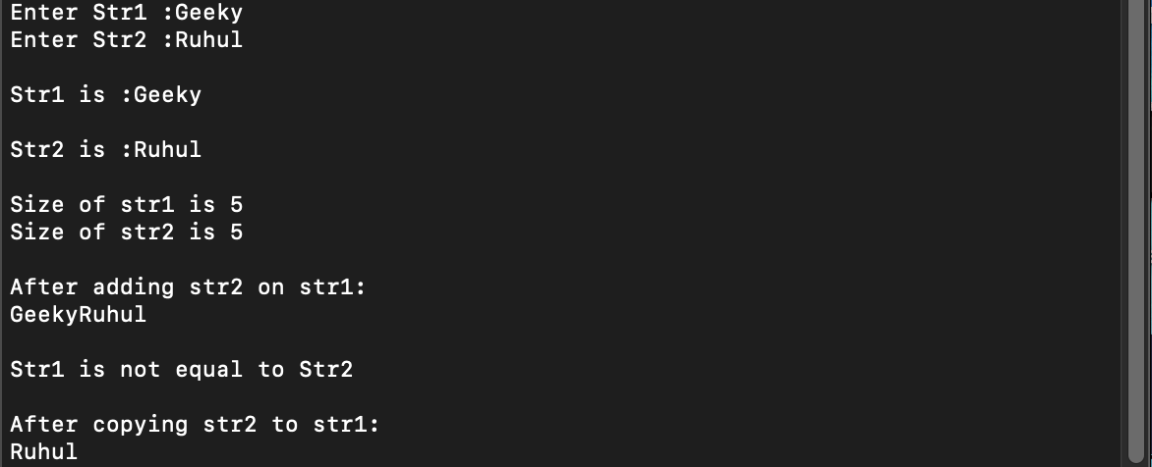

*//WACP to find the number of vowels, consonants, digits and special characters.*

*#include*<stdio.h>

*#include*<string.h>

*#include*<stdlib.h>

int main(){

char str[100];

printf("Enter the string:\n");

fgets(str,100,stdin);

*//puts(str);*

int vow=0, cons=0, dig=0, sc=0,i=0;

*while*(str[i]!='\0'){

*if*((str[i] >= 65 && str[i] <= 90) || (str[i] >= 97 && str[i] <= 122)){

*if*(str[i] == 'a' || str[i] == 'e' || str[i] == 'i' || str[i] == 'o' || str[i] == 'u'

|| str[i] == 'A' || str[i] == 'E' || str[i] == 'I' || str[i] == 'O' || str[i] == 'U')

vow++;

*else*

cons++;

}

*else* *if*(str[i]>='0' && str[i]<='9')

dig++;

*else*

sc++;

i++;

}

printf("\nNumber of vowels are: %d\n", vow);

printf("Number of consonants are: %d\n", cons);

printf("Number of digits are: %d\n", dig);

printf("Number of special characters are: %d\n", sc);

*return* 0;

}

**Output:**

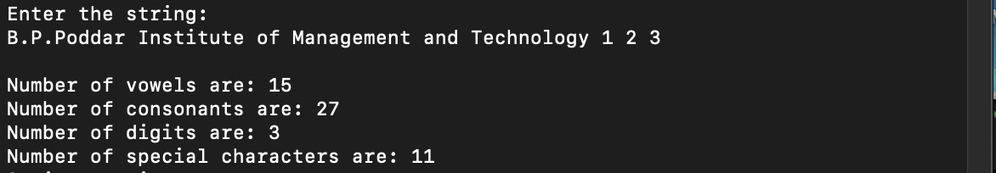

*//WACP to delete all vowels from a sentence.*

*#include*<stdio.h>

*#include*<string.h>

*#include*<stdlib.h>

int main(){

char str[100];

printf("Enter the string:\n");

fgets(str,100,stdin);

int i = 0;

int n = strlen(str);

*while*(str[i]!='\0'){

*if*((str[i] >= 65 && str[i] <= 90) || (str[i] >= 97 && str[i] <= 122))

{

*if*(str[i] == 'a' || str[i] == 'e' || str[i] == 'i' || str[i] == 'o' || str[i] == 'u'

|| str[i] == 'A' || str[i] == 'E' || str[i] == 'I' || str[i] == 'O' || str[i] == 'U')

{

*for*(int j = i ; str[j]!='\0' ; j++ ){

str[j]=str[j+1];

}

}

}

i++;

}

printf("After deleting all the vowels from the string: \n");

puts(str);

*return* 0;

}

**Output:**

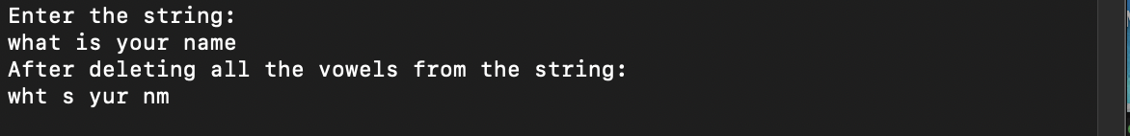

*//WACP to print the acronym of a name e.g. print D.V.C. for Damoder Valley Corporation.*

*#include*<stdio.h>

*#include*<string.h>

*#include*<stdlib.h>

int main(){

char str[100];

printf("Enter the string:\n");

fgets(str,100,stdin);

int n = strlen(str);

char acro[n];

int i,j=0;

acro[j] = str[0];

acro[++j] = '.';

++j;

*for*(int i=1 ; str[i]!='\0'; i++){

*if*(str[i]==' '){

acro[j]=str[i+1];

acro[j+1]='.';

j+=2;

}

}

int n2 = strlen(acro);

acro[n2]='\0';

printf("The acronym of %s is %s\n", str, acro );

*return* 0;

}

**Output:**

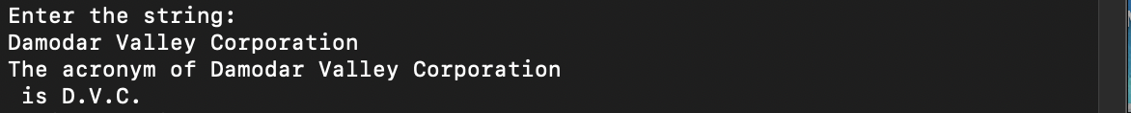

*//WACP to perform dictionary sorting.*

*#include*<stdio.h>

*#include*<string.h>

*#include*<stdlib.h>

int main(){

char str[5][100];

int res,i,j;

printf("Enter the string:\n");

*for*(int i=0; i<5; i++){

fgets(str[i],100,stdin);

}

int temp[5];

*for*(i=0; i<5; i++){

*for*(j=0; j<4-i; j++){

res = strcmp(str[j],str[j+1]);

*if*(res>0){

strcpy(temp,str[j]);

strcpy(str[j],str[j+1]);

strcpy(str[j+1],temp);

}

}

}

printf("After sorting:\n");

*for*(int i=0; i<5; i++){

puts(str[i]);

}

*return* 0;

}

**Output:**

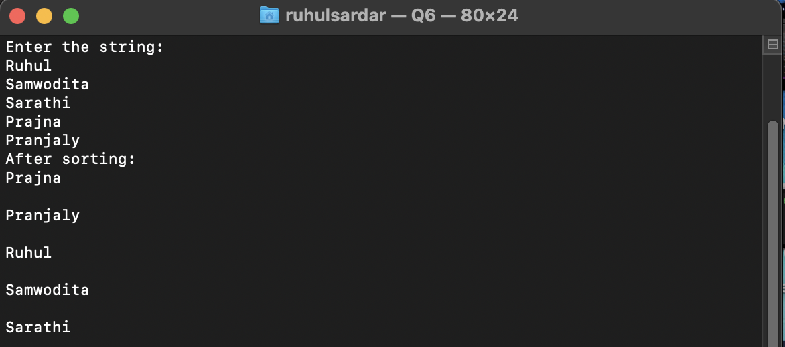

*// WACP to find whether a String is Palindrome or not.*

*#include*<stdio.h>

*#include*<string.h>

*#include*<stdlib.h>

int main(){

char str[100];

printf("Enter the string:\n");

fgets(str,100,stdin);

int n = strlen(str)-1;

int copy_of_str1[n];

strcpy(copy_of_str1,str);

int lo=0, hi=n-1, temp;

*while*(lo<=hi){

temp = str[lo];

str[lo] = str[hi];

str[hi] = temp;

lo++;

hi--;

}

int ret = strcmp(copy_of_str1,str);

*if*(ret == 0){

printf("Yes palindrome\n");

}

*else*

printf("Not palindrome\n");

*return* 0;

}

**Output:**

